

<type your title here>
reverse engineering PROJECT REPORT
Submitted by
<STUDENT NAME> | <ROLL NO>

in partial fulfillment of the requirements for the degree of
BACHELOR OF ENGINEERING
in
<XXX ENGinEERING>
Dr. MAHALINGAM COLLEGE OF ENGINEERING AND TECHNOLOGY
An Autonomous Institution
Affiliated to ANNA UNIVERSITY
CHENNAI 600 025

<XXX 2025>

DR. MAHALINGAM COLLEGE OF ENGINEERING AND TECHNOLOGY, POLLACHI -642 003
(An Autonomous Institution Affiliated to Anna University, Chennai - 600 025)
Bonafide CERTIFICATE
Certified that this Reverse Engineering project report titled “<Project title>” is
the bonafide work of
<STUDENT NAME> | <ROLL NO>

who carried out the Reverse Engineering Project work under my supervision.

XXX M.E., Ph.D.,  PROFESSOR AND HEAD  Department of XXX  Dr.Mahalingam college of  Engineering and Technology  Pollachi- 642003 | <SUPERVISOR NAME>.,  SUPERVISOR  <Designation>  Department of XXX  Dr.Mahalingam college of  Engineering and Technology  Pollachi- 642003
Submitted for the Autonomous End Semester Reverse Engineering Project work Viva-Voce Examination held on ___________________

INTERNAL EXAMINER EXTERNAL EXAMINER
Dr. Mahalingam College of Engineering and Technology, Pollachi-642003
Academic Year: 20_ _ - 20_ _
TRL, SDG and Similarity Compliance Certificate
Project Title:
Course Code:
Department and Semester:

Technology Readiness Level (TRL) of the Project : _____________
Sustainability Development Goals (SDG)-Goal Name : ______________
Similarity % from Turnitin Software : ________________

S.No. | Names and Roll Numbers of Students | Signature of the Students
I/we hereby declare that this Reverse Engineering Project report is original and complies with the institution's similarity guidelines.

Verified by

Name & Signature of the Guide Head of the Department

Endorsed by

INTERNAL EXAMINER EXTERNAL EXAMINER

ABSTRACT
Recent technological developments in optics and photonics have been drastically influenced by the field of nonlinear optics. Nonlinear optical phenomena plays a pivotal role in many special optical device functions such as direct optical amplification.

ACKNOWLEDGEMENT

We wish to express our sincere thanks to all who have contributed to do this project through their support, encouragement and guidance.
We extend our gratitude to our management for having provided us with all facilities to build my project successfully. We express our sincere thanks to our honourable Secretary, Dr.S.V.Subramanian, MBA., Ph.D., for providing the required amenities.
We take this opportunity to express our deepest gratitude to our principal Dr.P.Govindasamy, Ph.D., who provide suitable environment to carry out the project.
We express our extreme gratefulness to XXX M.E., Ph.D., Professor and Head of the department of XXX Engineering, for his/her constant support and encouragement.
We wish to express our deep sense of gratitude and thankfulness to my project guide _______., for the valuable suggestion and guidance offered during the course of the project.
Finally, we are committed to place our heartfelt thanks to all those who had contributed directly and indirectly towards the success of the completion of this project.
.

TABLE OF CONTENTS

CHAPTER NO. TITLE PAGE NO.
ABSTRACT V
LIST OF TABLES VIII
LIST OF FIGURES IX
LIST OF ABBREVIATIONS X
- product Introduction 1
1.1 Product Description. 1

1.1.1 …. 2
1.2 Objectives 2
1.3 Literature (if any) 3
- Methodology and Process involved 5
2.1 Tools and Equipment/software specifications

2.1.1 …. 6
2.2 Process/Steps Followed/data flow diagram

2.2.1 …. 7
- Findings & Results 8
3.1 System-Wide Analysis/system design 9

3.1.1 …. 9
3.2 Subsystem Dissection Analysis 10

3.2.1 …. 10
3.3 Individual Component Analysis 11

3.3.1 …. 11
- Discussion & Analysis 12
4.1 Design Analysis 12

4.1.1 …. 13
4.2 Challenges/Issues 14

4.2.1 …. 14
- conclusion 15
4.1 key findings and outcomes of the project 15

4.1.1 …. 16
4.2 Suggestions for future work or applications. 17

4.2.1 …. 17
APPENDIX 1 18
REFERENCES 19

LIST OF TABLES
TABLE NO | TITLE | PAGE NO
1.1 | xxx | 25
3.1 | xxx | 23
5.1 | Variation of p xxx | 28
2.5 | xxx | 29
2.8 | xxx | 35
3.1 | xxx | 25
5.1 | xxx | 26

LIST OF FIGURES
FIGURENO | TITLE | PAGE NO.
2.1 | Experimental arrangement for the measurement of Ultrasonic velocity in liquids | 16
2.2 | Ultrasonic Interferometer (Model F-05) the measurement of Ultrasonic velocity in liquids | 16
2.3 | Cross Section of measuring cell | 17
2.4 | Position of reflection ˅s Crystal current | 17
2.6 | Experimental arrangement for the measurement of ultrasonic velocity in liquids | 28
2.7 | Ultrasonic interferometer (Model F-05) the measurement of ultrasonic velocity in the liquid | 2

LIST OF Symbols andABBREVIATIONS

ALU - Arithmetic Logic Unit
ANSI - American National Standards Institute
CPU - Central Processing Unit
CP - Compression Ratio
RGA - Relative Gain Array

chapter 1

product Introduction
This chapter emphasize the significance and characterization of liquid mixtures using ultrasonic method. A brief review of literature pertaining to the present work is also presented.

product description
Matter exists in three different forms which are solid, liquid and gas. The most striking difference between a liquid and solid is that a liquid does not permanently resist the forces tending to change its shape. A liquid possesses neither the rigidity of a solid nor the fluidity of a gas and so itexhibits properties intermediate to both the states. (Temperly and Trevena 1978)produced definite evidence that liquids can withstand tensions of at least tens of atmospheres. Thus, forces between molecules are attractive at large distances and a liquid resists changes of density and cannot resist changes of shape.
Matter exists in three different forms whichare soliliquid and gas. The most striking difference between a liquid and solid is that a liquid does not permanently resist

xxxx
A number of theories of the liquid state are based on the concept of lattice structure in a liquid. A liquid may be considered as a disordered solid. Liquids are sometimes classified like crystals based on the kind of cohesive forces that hold them together. Ionic liquids consist of ions and electrons. Water molecules are held together by Hydrogen bonds. In many molecular liquids, cohesion is due to Vander Waals forces between essentially saturated molecules. Even when other forces are present contribution due to Vander Waals force is always large, which was studied by (Morrison and Nelson 2001)Thewell ordered arrangement of units in solids is the key difference between solids and liquids. In a liquid, the orderly arrangement extends over a short range of around five to six molecular diameters and there is long range disorder. Near the melting point, the densities of the crystal and its liquid are nearly the same. The structure of a liquid is continuously changing because of thermal motions of the individual molecu(Allington 2009)les, that was reported by (Moore 1965). So the properties of the liquid are determined by the time average of a large number of arrangements. During recent years, the theory of the liquid state has attracted a considerable attention and several working models for liquid state have been proposed which consist in idealizing a liquid to make it amenable to statistical treatment.

objectives
When materials mix together to form solutions, the mixing happens at the molecular level and depends on intermolecular bond types. Suppose A & B are mixed. In the process the bonds holding A together (A-A) and bonds holding B together (B-B) are broken. New bonds holding A & B are formed. In some ways this is like elements combining to form a compound. It is not necessary for there to be a fixed ratio here. In this case, there can be any number of A’s mixed in with the B’s. This process can be exothermic or endothermic depending on the strength of the bonds involved and whether more or less energy is released in making A-B bonds than is used in breaking A-A and B-B bonds. The interaction that exists in a liquid or solution is of two types viz., the long range and the short range. The highly directional long range interact include characteristic induction and dispersion forces which arise without overlap of electron clouds due to the closer approach of interacting molecules. In the long range interaction, London forces or Vander Waals forces may be included. The short range interactions such as dipole-dipole interactions, dipole- induced dipole, charge transfer, complex formation and hydrogen bonding arise when molecules come closer together resulting in significant overlapping of electron clouds.

LITERATURE
The relay feedback test for process control practitioners as a closed loop tool for system identification and control (Astrom and Hagglund 1984). A systematic approach to derive the analytical expressions for limit cycle oscillations of various benchmark SISO processes (Panda and Yu 2003). The progress in the relay feedback auto tuning is comprehensively documented in the book by Yu (1999). (Panda et al 2011) formulated an identification algorithm to estimate the model parameters of SOPDTand severalintegrating usinglandmark point’s information on relay responses.Relative Gain Array (RGA) is the most discussed method for analyzing interactions and it is based on steady state gain information of MIMO processesBristol (1966). A different approach for investigating channel interaction was employed by (Conley and Salgado 2000),when considering observability and controllability gramians in so called Participation Matrices (PM). In a similar approach (Witten mark and Salgado 2002) introduced the Hankel Interaction Index Array (HIIA).(Luyben 1986) proposed a simple, easily implemented procedure for controller tuning in multivariable systems and it was successfully tested on 10 different systems taken from the distillation literature. The automatic tuning of multivariable systems based on the concept of sequential identification design and proved that MIMO auto tuner works well for very difficult processes in a transparent manner(Shen et al 1994). In the present work, an attempt is made to identify the process and disturbance model parameters using the mathematical modeling of undesired relay response and then to retune the controller parameters using optimization method and extending IMC-PI controller tuning using Laurent series to MIMO systems.
Early landmarks included Pierce’s quartz-driven ultrasonic interferometer (Blitz 1967) and the discovery in 1932 by Debye and Sears and also by Lucas and Biquard of the ultrasonic diffraction grating. Ever since, the field has grown enormously with wide applications in science, medicine and other areas. (Graff 1982) investigated physical, chemical and biological effects of ultrasounds on macromolecules, microorganisms and cells (Stokes 1845) made the first attempt in medical imaging using ultrasonics.
Select this option to allow reviewers to use restricted styles when automatically formatting text such as hyperlinks or automatic bullets. For example, if you select this check box, Word will automatically format hyperlinks, even if the Hyperlink style is locked.

methodology and process involved

A detailed experimental procedure adopted in this investigation is presented in this chapter. In addition, the theoretical formulations involved in the computation of various acoustic parameters are also discussed.

tools and equipment

process/steps followed

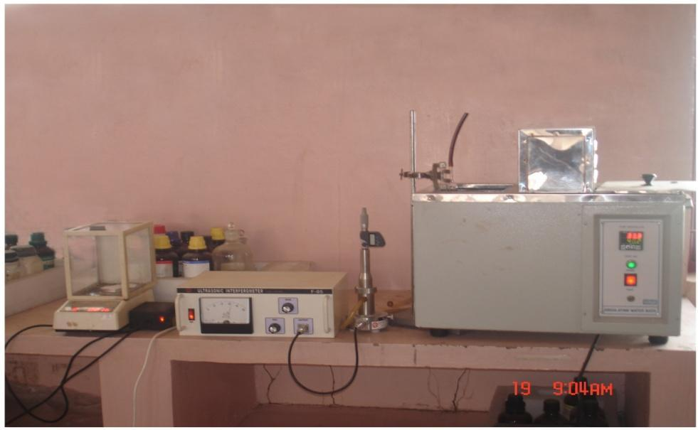

Figure 2.1 Experimental arrangement of ultrasonic velocity

measurement in the liquid

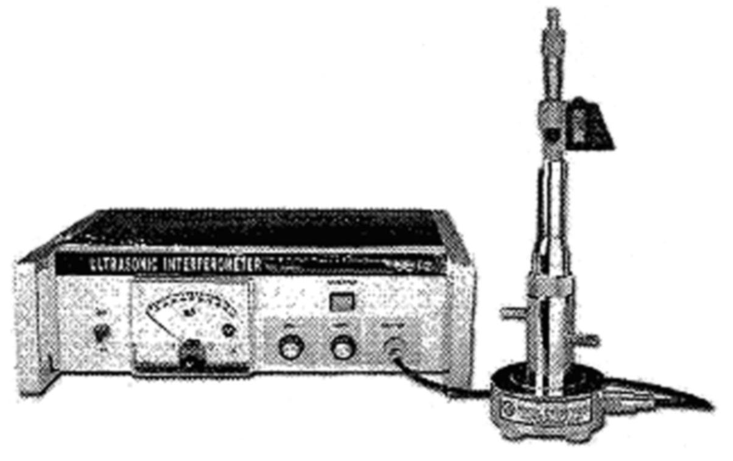

Figure 2.2 Experimental arrangement of ultrasonic

velocity measurement in the liquid

xxx

xxx
The principle used in the measurement of ultrasonic velocity is based on the accurate determination of the wavelength in the medium. A quartz plate fixed at the bottom of the measuring cell produces ultrasonic waves of known frequency. These waves travel through the liquid and are reflected back by a movable metallic plate kept parallel to the quartz plate. If the separation between these two plates is an integral multiple of half wavelength, standing waves are setup in the medium. The reflected waves arriving back at the crystal surface are out of phase. The resulting decrease in the amplitude of crystal oscillations is accompanied by alternating currentthrough the crystal. The driving oscillator is loosely coupled to an LC circuit with a quartz plate in parallel and the same is tuned to the resonating frequency of the crystal. The acoustic resonance gives rise to an electrical reaction on the generator driving the quartz plate and the anode current of the generator attains maximum.
When the position of the reflector is changed and the distance is increased or decreased and the variation is exactly one half of the wavelength or multiple of it, anode current gain attains the maximum value. Knowing the crystal frequency (f) and wavelength (λ), the Ultrasonic velocity (U) of sound in the medium can be obtained by the relation,
$U=$λ$A=πr^{2}$ (2.1)

Table 2.1 xxxx
S.No. | Liquid | Ultrasonic velocity U (ms-¹)
S.No. | Liquid | Observed | Literature | Reference
 |  | Value | Value | Reference
1. | Cyclohexane | 1230.33 | 1230.30 | Vasantharani et al
 |  |  |  | (2009)
2. | 1-Propanol | 1193.40 | 1194.00 | Thirumaran&
3. | 1-Butanol | 1230.15 | 1237.10 | Thenmozhi (2010)
4. | 1-Pentanol | 1252.90 | 1258.20 | Palani et al (2009)
5. | 1-Hexanol | 1288.49 | 1289.10 | Kannappan et al
 |  |  |  | (2009)

APPENDIX

REFERENCES
- Aghion, P & Durlof, S 2005, Handbook of Economic Growth, Elsevier books, Amsterdam.
- Albert, Le 1975, Nuclear Model, Hoxen, New York.
- Alishahi, K.L , Marvasti, F & Aref Lee Mathew 2009, 'Bounds on the sum capacity of synchronous binary CDMA channels', Journal of Chemical Education, Vol. 55, no. 8, pp. 3577-3593.
- Allington Bennett Lementon 2009, How to write, PHI, New York.
- Allington 2009, 'How to write Bibliographies', Bibliographies Methodology, Vol. 100, p. 55.
- Australian Securities. 2009. Market information. Available from : <http://www.asx.com.au/professionals/market_information/index.htm> [05 July 2009].
- Morrison, RT & Nelson, BR 2001, Organic Chemistry, Prentice Hall of India Pvt. Ltd., New Delhi.
- Riley, D 1992, 'Industrial relations in Australian Education', in Contemporary Australasian industrial relations : proceeding of the sixth AIRAANZ conference , ed. Blackmur, AIRAANZ, Sydney, pp. 124-140.
- Samuel, S 2006, Inorganic Chemistry, Oxford, NewDelhi.
- Sarbjeet singh & Seema Bawa 2010, Enabling Trust and Privacy based Access for grid services.
- Temperly & Trevena, DH 1978, Liquids and their properties, John Wiley and Sons, New York.

